**RELAYS**

https://www.youtube.com/watch?v=n594CkrP6xE

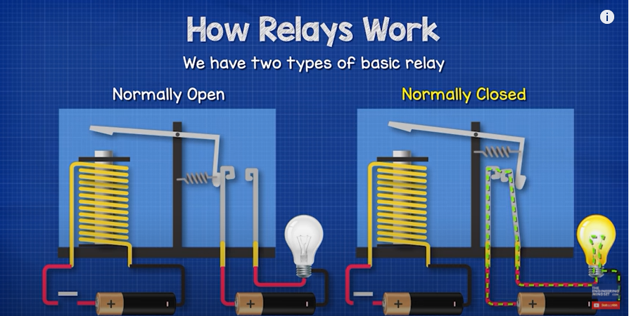

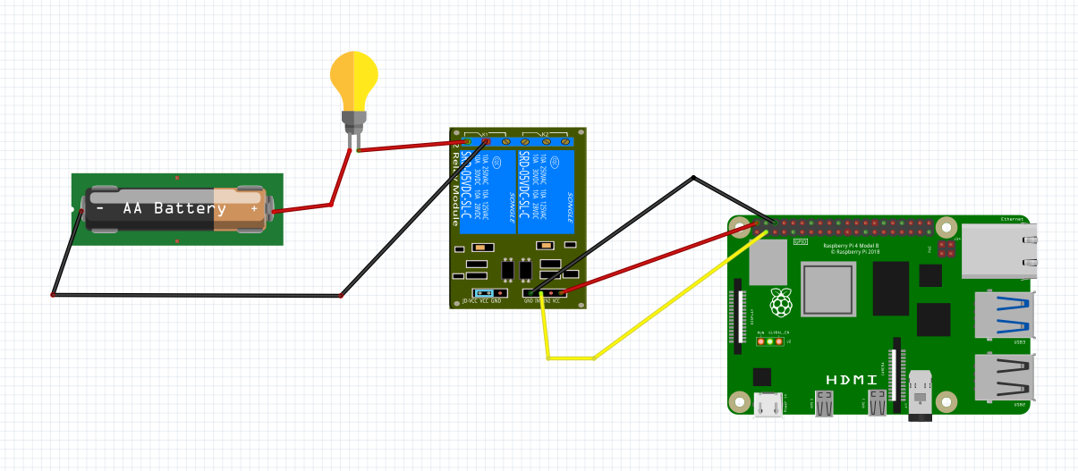

COMMON 1

NO – Normally Open

IN2

IN1

IN1 to Pin 2

IN1 – Connected to PIN 2

SAMPLE CODE FOR NORMALLY OPEN CONNECTION

import RPi.GPIO as GPIO

from time import sleep

GPIO.setwarnings(False)

GPIO.setmode(GPIO.BCM)

GPIO.setup(2,GPIO.OUT)

GPIO.output(2,GPIO.LOW)

sleep(10)

GPIO.output(2,GPIO.HIGH)